**Morpho-Anatomical Study of Leaves of *Adhatoda vasica* L. and *Sambucus hookeri* L. Growing in Kathmandu, Nepal**

**Ratna Silwal Gautam1,*, Belai Meeta Suwal Singh2**

|  |  |
| --- | --- |
| **Author’s Affiliation**  1,2Department of Botany, Patan Multiple Campus Tribhuvan University, Kathmandu Nepal | **\*Corresponding Author:**  **Ratna Silwal Gautam**  Department of Botany, Patan Multiple Campus  Tribhuvan University, Kathmandu Nepal  **E-mail:**  [silwalratna@gmail.com](mailto:silwalratna@gmail.com)    **Received on 14.03.2020,**  **Accepted on 22.05.2020** |

|  |  |
| --- | --- |
| ***Keywords****:*  Urban vegetation,  Air pollution, Morphology  Anatomy. | ***Abstract***  *Urban vegetation acts as eco-sustainable filter for air pollution of the city. The foliar surface of urban roadside plants acts as a sink for particulate matter depositions which affects the morphological, physiological, anatomical and biochemical properties of leaves. This study aims to find out the morphological and anatomical differences of leaves of Adhatoda vasica and Sambucus hookeri plants growing in two different regions of Kathmandu. Measurement of leaf morphological and anatomical parameters was performed for the comparative study. The study showed that the leaf length, the leaf breadth and the leaf area in Adhatoda vasica were found more in the leaves from ringroad area than the raniban area. The leaf dry mass content was found less in the leaves from ringroad area than the raniban area. In Sambucus hookeri, the leaf length, leaf breadth and leaf dry mass content were found more in the ringroad area than the raniban area. The leaf area in the leaves from the ringroad area was found less than the leaves of the raniban area. The stomata frequency in the peel from lower surface of leaf was found less in the both Adhatoda vasica and Sambucus hookeri from the ringroad area than the leaves from the raniban area. Thickness of the cuticle, length and breadth of the epidermal cell were found more in the leaves of plant growing in the ringroad than the raniban area. The thickness of palisade and the thickness of spongy parenchyma layers were found no different in the both study sites of these two plants.* |

**INTRODUCTION**

Research conducted in the past has shown that the plants growing in roadside or pollution stress area possess some morphological and anatomical changes than the plants growing in control sites. In mega cities automobile activities are major source of air pollution and produce toxic effects on plant growth (Akhter, *et al.,* 2018). Pollution due to toxic gases emissions affects the plants growing in many urban areas (Quadir & Iqbal, 1991). Pollutants effect the morphological, anatomical, physiological and biochemical characters of the plant (Pandey *et al.,* 2006). In urban environment, trees play an important role in improving air quality by absorbing gases and particles (Woo & Je, 2006). Foliar surface of urban roadside plants acts as a sink for particulate matters depositions and through their depositions they show specific morphological, physiological and biochemical parameters of plants of an urban area now being investigated as an integral part of air pollution science (Rai, 2016). Road traffic is the main cause of air pollution in the metropolitan cities due to harmful emissions (Gidde & Sonawane, 2012). Similarly, industrial processes also add significant quantity of carbon monoxide in the city (Karmacharya & Shrestha, 1991). Leaves are usually the site of injury by pollutants that enter the leaves mostly through stomata. Deposition of pollutants on moist leaves results in the annular chlorosis or bleached patches on laminar surface (Chaphekar, 1982). On the morphological point of view, the plants from polluted sites present important changes especially regarding their colors, shapes, leaf length, width, area and petiole length. Despite of these changes plants were survived well at the polluted environment. It has been accounted for that morpho-anatomical adjustments are promising measures to gauge the air quality of the urban habitat (El-Khatib *et al*., 2011). Studies on impact of micro-morphology and leaf epidermal components of plants revealed that in the polluted sites, leaves became smaller with reduced length and width and stomata index per leaves area (Saadabi, 2011). There is steady extension of toxic gasses and other substances arising from rapid growth of industries and automobile vehicles (Jahan & Iqbal, 1992). Leaf is the most sensitive and exposed part to be affected by air pollutants instead of all other plant parts such as stems and roots (Leghari & Zaidi, 2013). Urban air pollution is an environmental problem in developing countries (Mage *et al*., 1996). In urban environment, trees play an important role in improving air quality by absorbing gases and particles (Woo & Je, 2006). Plants leaf acts as the scavengers for many air borne particulates in the atmosphere (Joshi & Swami, 2009).

Kathmandu is Nepal’s largest urban center with an annual population growth rate five percent. Air quality in Kathmandu is regularly surpassed very unhealthy levels and even reached hazardous in March and April 2016 (http//www.iied.org/clearing- air- Kathmandu). The valley’s unique shape prevents the escape of industrial and vehicular emissions. In the last one decade, the number of vehicles in the capital city has been tripled. Two thirds of deadly pollutants are caused by vehicular emissions and dust according to Ministry of Health, Nepal Government (2017). Due to high vehicular emission and dust, ring road is considered as highly polluted sites whereas Raniban forest, a part of preserved Shivapuri Nagarjun National Park, is generally considered as less polluted sites and hence it is selected as controlled site. All available literatures reveal that there is little information on the effects of air pollutants on plant tissues. Hence the present study is carried out on some morphological as well as anatomical characteristics of two common roadside shrubs of the city. In this study two common roadside shrubs of ringroad Kathmandu were selected. These two plants were *Adhatoda vasica* and *Sambucus hookeri. Adhatoda vasica*, commonly known as Asuro in Nepali is a shrub about 2 m height of the family Acanthaceae. It is distributed throughout Nepal to about 2700 m in open areas and uncultivated land. The tender leaves and flowers are cooked as vegetables. Juice of leaves is useful for cough, bronchitis, malaria and asthma. *Sambucus hookeri*, commonly known as Jaliphool in Nepali is a shrub about 3.5 m height of the family Caprifoliaceae. It is distributed throughout Nepal at 200-3700 m in an open place. (Manandhar, 2000) (Figure 1 & 2).

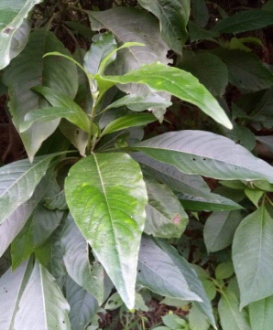 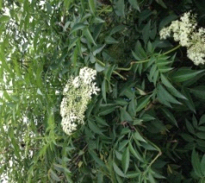

**Figure 1: *Adhatoda vasica* Figure 2: *Sambucus hookeri***

**MATERIALS AND METHODS**

Leaf samples were collected in the month of November, 2017 from the plants having similar diameter, uniform height and similar growth form from both study sites. Leaves were brought to the laboratory in polyethene bags and some of them were preserved in formalin for the anatomical study. For the calculation of the specific leaf dry mass content, leaves were kept in hot air oven for two hours at 100°c. Leaves area was determined by using graph paper. The length and the breadth of leaves were measured in centimeters using scale. Study of stomata of lower surface of leaves was performed from the lower epidermal peel using calibrated optical microscope.

Thin anatomical sections were made from the preserved leaves and observed under calibrated microscope. Quantitative measurement of the thickness of cuticle, the size of epidermis, the thickness of palisade layer and the thickness of spongy parenchyma was done using calibrated microscope. Permanent slides were prepared after completion of alcohol dehydration series. Leaves samples for all necessary data were taken in five replicates. All the data were tabulated in Microsoft Excel 2013.The standard error and the standard deviation values of the means were calculated for a comparison of two sites.

**RESULTS AND DISCUSSION**

The measurement of leaf morphological and anatomical parameters showed that the leaf length, the leaf breadth and the leaf area in *Adhatoda vasica* were found more in the leaves from ringroad area than the raniban area. The leaf dry mass content was found less in the leaves from ringroad area than the raniban area. In *Sambucus hookeri*, the leaf length, leaf breadth and leaf dry mass content were found more in the ringroad area than the raniban area. The leaf area in the leaves from the ringroad area was found less than the leaves of the raniban area. The stomata frequency in the peel from lower surface of leaf was found less in the both *Adhatoda vasica* and *Sambucus hookeri* from the ringroad area than the leaves from the raniban area. Thickness of the cuticle, length and breadth of the epidermal cell were found more in the leaves of plant growing in the ringroad than the raniban area. The thickness of palisade and the thickness of spongy parenchyma layers were found no different in the both study sites of these two plants (Table 1 & 2. Figure 3, 4, 5 & 6).

**Table 1: Measurements of leaf parameters of *Adhatoda vasica* in two study sites**

(SE= standard error, SD= standard error, Min. = minimum, max.= maximum)

**Table 2: Measurements of leaf parameters of *Sambucus hookeri* in two study sites**

(SE= standard error, SD= standard error, Min. = minimum, max.= maximum)

As the air pollution has diverse effects on morphology, physiology as well as anatomy of the plant, the present work was mainly focused on leaf morphology and leaf anatomy of two common plant species which were dominantly found in the ring road area of Kathmandu city. In plant organs, the leaf is the most sensitive part to be affected by air pollutants. Therefore, leaf at its various stage of development serves as a good indicator to air pollutants (Shafig, 2002). The leaves of trees which were growing in the highly polluted areas of Kathmandu were observed morphologically damaged i.e. wilting of leaves, defoliation of leaves, chlorosis, necrosis etc. Chlorosis and necrosis were mostly observed in *Adhatoda vasica* whereas the wilting was mostly observed in *Sambucus hookeri.*

The leaf lengths and leaf breadth of *Adhatoda vasica* and *Sambucus hookeri* were found different in roadside and raniban forest area. Similar type of study was performed by various researchers. Sayyednejad *et al.* (2009) have found the increase in leaf length in the leaves of *Albizia lebbeck* under the stress of air pollution but Leghari & Zaidi (2013) have found the significant reduction of leaf length at polluted sites when compared to non-polluted sites. Reduction of leaf breadth was observed by Leghari & Zaidi (2013) and Assadi *et al*., (2011) in the plants growing in the air pollution stress sites. The leaf area of *Adhatoda vasica* growing in the ringroad area was found more than the leaves growing in the raniban area. On contrary to the present results, Dineva (2004), Tiwari (2006), Jahan & Iqbal (1992), Sayyednejad *et al*., (2009), Leghari & Zaidi (2013), Asadi *et a*l., (2011) and Mahajan *et al*., (2015) have found the reduction of leaf area under pollution stress condition. Tiwari *et al.,* (2006) have found the reduction of leaf area and leaf number in pollution stress area. This reduction may be due to decreased leaf production rate and enhanced senescence. The leaf dry mass contents of *Adhatoda vasica* and *Sambucus hookeri* were found different in two study sites. Bhatti and Iqbal (1988) have found that the automobile emission significantly reduced the leaf dry weight of *Guaiacum officinale L., Ficus benghalensis* and *Eucalyptus* species at the polluted city of Karachi. Hussain *et al. (*1997) also found decrease in leaf fresh and dry weight of roadside plant *Bougainvillea spectabilis* Wild.

The stomatal frequency in *Adhatoda vasica and Sambucus hookeri* were found less in the plants growing in the ringroad area than the leaves growing in the raniban area. Similarly, Raina & Sharma (2006) and Raina & Bala (2007) have reported decrease in frequency of stomata in polluted areas. Whereas, Yunus and Ahmed (1979) observed higher stomatal density in the plants from polluted sites which also supports the view of Raina & Sharma (2003), Pal *et al*., (2000), Salgare & Iyer (1991) and Yunus *et al.,* (1982).

In the present work the thickness of cuticle, the length of epidermal cells and the breadth of epidermal cell were found more in the leaves growing in ringroad area than the leaves from raniban area whereas Empemerechi *et al.,* (2017) have observed the reduction in the thickness of cuticles is a response of plants to exposure of the leaves to pollutants since it is the first tissue exposed to pollutants among all other plant tissues. Pourkhabbaz *et al*., (2010) have observed thin cuticle in the plants of urban areas. Jafari *et al.* (1979), Farooq *et al.,* (1995) and Gostin, (2009) have found smaller size of epidermal cells in the highly polluted sites. Raina and Chand (2011) have found that spongy tissue decreases significantly in vehicular polluted areas whereas palisade/ spongy tissue ratio and palisade remain unaffected.

**Figure 3: Measurements of leaf parameters of *Adhatoda vasica* in two study sites**

**Figure 4: Measurements of leaf parameters of *Sambucus hookeri* in two study sites**

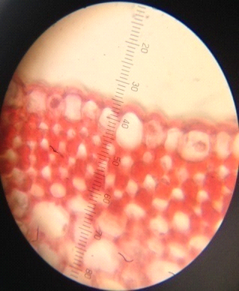 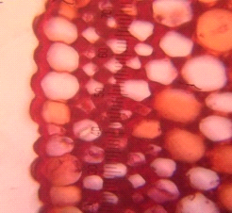 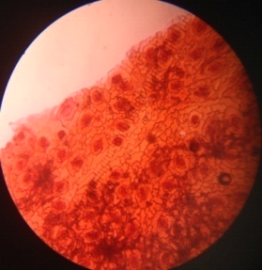 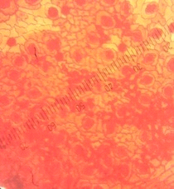

a b c d

**Figure 5: *Adhatoda vasica*, Leaf anatomy- a) Ringroad area b) Raniban area Epidermal peel – c) Ringroad area d) Raniban area**

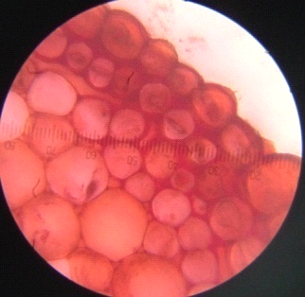 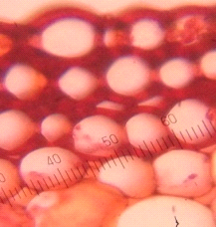 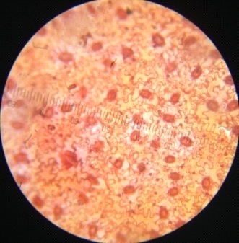 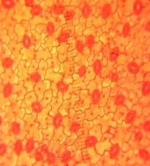

a b c d

**Figure 6: *Sambucus hookeri*, Leaf anatomy - a) Ringroad area b) Raniban area Epidermal peel - c) Ringroad area d) Raniban area**

**CONCLUSION**

This study focused on morphological and anatomical differences in the shrub plants namely *Adhatoda vasica* L. and *Sambucus hookeri* L. growing in two different regions of Kathmandu. Ringroad area is central part of Kathmandu city with high vehicular emissions and Raniban area is a part of preserved Shivapuri Nagarjun national park. The leaf morpho- anatomical study of these plants revealed that these two shrub plants are not showing many differences in measurement parameters and growing in healthy conditions in both study area. These plants having medicinal and ornamental values can be easily grown in road sides of urban areas like Kathmandu.

**ACKNOWLEDGEMENT**

The authors are thankful to University Grant Commission for providing financial support and Patan Multiple Campus, Botany Department for providing laboratory facilities for the research work.

**REFERENCES**

1. Akhter, A., Iqbal, M. Z. and Shafig, M. (2018). Effects of traffic related pollution on some morphological characteristic of street tree *Azadirachta indica* A-Juss (Meliaceae). *Scientia Agriculturae*, 21(1):1-5.
2. Assadi, A., Ghasemi, A., Pirbalouti, A. G., Malekpoor, F., Teimori, N. & Assadi, L. (2011). Impact of air pollution on physiological and morphological characteristics of *Eucalyptus camaldulensis. Journal of Food, Agriculture & Environment*, 9(2): 676-679.
3. Bhatti, G.H., & Iqbal, M.Z. (1988). Investigations into the effects of automobile exhausts on the phenology, periodicity and productivity of some roadside trees*. Acta Societies Botananicorum Poloniac,* 57: 395-399.
4. Chaphekar, S.B. (1982). Air pollution of plants. *Indian Review of life Science,* 2: 41-56.
5. Dineva, S. B. (2004). Comparative studies of the leaf morphology and structure of white ash *Fraxinus americana* L. and London plane tree *Platanus acerifolia* Willd growing in polluted area. *Dendrobiology, 52*: 3-8.
6. EL-Khatib, A., Al-Sayed, K. N. & Youssef, N. (2011). Bio-monitoring of airborne dust Particles pollutants by morpho-anatomical reactions of urban tree leaves under dry climate. *Egyptian journal of Botany,* 51(1): 1-12.
7. Epkemerechi, S. & Ayokun-num, A. & Jimoh, M. & Saheed, A. (2017). Variation in leaf anatomical characters in response to air pollution in some Euphorbiaceae species. *West African Journal of Applied Ecology*, 25(1):21-31.
8. Gidde, M. R. & Sonawane, P. P. (2012). Assessment of traffic related air pollution and ambient air quality of metropolitan cities. (A case study of Pune city). *Journal of Engineering,* 2(6): 1582-1590.
9. Gostin, I. N. (2009). Air pollution effects on leaf structure of some Fabaceae family species. *Notulae Botanical Horti Agrobotanici Cluj-Napoca,* 37(2): 57-63.
10. Hussain, F., Shah, Z. & Durrani, M. J. (1997). Effect of air borne particulate pollutants on the growth of some roadside cultivated plants. *Pakistan Journal of Plant Science*, 3: 73-82.
11. Jafri, S., Srivastava, K. & Ahmad, K. J. (1979).Environmental pollution and epidermal structure in *Syzygium cumini* L. Skeel. *Indian Journal of Air Pollution Control*, 2: 74-77.
12. Jahan, S. & Iqbal, M. Z. (1992). Morphological and anatomical studies of leaves of different plants affected by motor vehicles exhaust. *Journal of Islamic Academy of Sciences,* 5: 21-23.
13. Joshi, P. C. & Swami, A. (2009). Air pollution included changes in the photosynthetic pigments of selected plant species. *Journal of Environment Biology*, 30(2): 295-298.
14. Karmacharya, A.P. & Shrestha, R.K. (1991). Air *Quality Assessment in Kathmandu City,* Kathmandu Environment and Public Health Organization (ENPHO), Kathmandu, Nepal.
15. Leghari, S.K. & Zaidi, M.A. (2013). Effect of air pollution on the leaf morphology of common plant species of Quetta City. *Pakistan Journal of Botany,* 45(S1): 447-454.
16. Mage, D., Ozolins, G., Peterson, P., Webster, A., Orthofer, R., Vandeveerd, V. & Gwynne, H. (1996). Urban air pollution in megacities of the world. *Atmospheric Environment*, 30: 681-686.
17. Mahajan, S., Maviya, N. & Pathak, R. (2015). Effect of environment pollution on roadside plants in Indore city. (M.P.) India, 3(05). [www.ijates.com](http://www.ijates.com/) ISSN (online): 2348-7550.
18. Manandhar, N.P. (2000). Plants and People of Nepal. Timber press, Inc. Portland, Oregon, USA.
19. Pal, A., Kulshreshtra, K., Ahmed, K. J. & Junus, M. (2000). Changes in leaf surface structures of two tree species caused by auto exhaust pollution. *Journal of Environment Biology,* 21 (1): 15-21.
20. Pandey, S., Kumar, N. and Kushwahar, R. (2006). Morpho-anatomical and physiological leaf traits of two alpine herbs, *Podophyllum hexandrum* and *Rheum emodii* in the western Himalaya under different irradiances. *Photosynthetica,* 44: 11-16.
21. Pourkhabbaz, A., Rastin, N., Olbrich, A., Langenfled, H. & Polle, A. (2010). Influence of environmental pollution on leaf properties of urban plane trees, *Platanus orientalis* L. *Bulletin of Environmental Contamination and Toxicology*, 85(3): 251-255.
22. Qadir, S. A. and Iqbal, M. Z. (1991). Growth of some plants raised from polluted and unpolluted seeds. *International Journal of Environmental Studies,* 39: 95-99.
23. Rai, P. K. (2016). Impacts of particulate matter pollution on plants: Implications for environmental biomonitoring*. Ecotoxicology and Environmental Safety,* 129: 120-136.
24. Raina, A. K & Chand, B. (2011). Effect of vehicular pollution on *Duranta repens* L. in Jammu city. *Journal of applied and natural sciences*, 3(2): 211-218. DOI: 10.31018/jans.v3i2.181.
25. Raina, A. K. & Sharma, A. (2003). Effect of vehicular pollution on the leaf micro-morphology, anatomy and chlorophyll contents of S*yzygium cumini* L. *Indian Journal of Environmental Protection,* 23(8): 897-902.
26. Raina, A. K. & Sharma, A. (2006). Assessment of air pollution and its impact on the leaves of some plant species. *Pollution Research, 25*(3): 543-547.
27. Raina, A. K., & Bala, C. (2007). Effect of vehicular pollution on *Polyalthia longifolia* Benth. & HK. f. and *Ipomoea carica* (L.) Sweet in Jammu, J. & K. *Environment & Ecology*, 25(4): 1103-1109.
28. Rao, M.V., & Dubey, P. S. (1991). Detoxifying mechanism: probable role in determining the plant response to SO2 under different light intensities. *Indian Journal of Environment and Toxicology*, 1(1): 39-45.
29. Saadabi, A. M. A. (2011). Effects of auto-exhaust pollution on the micro-morphology and leaf Epidermal features of ornamental plants in Khartoum, Sudan. *Journal of Applied Sciences Research,* 7(3): 270-273.
30. Leghari, S. K. and Zaidi, M. A. (2013). Effect of air pollution on the leaf morphology of common plant species of Quetta city. *Pakistan Journal of Botany*, 45(S1): 447-454.
31. Salgare, S. A., & Iyer, M. P. (1991). Effects of auto-exhaust pollution on the micromorphology of some weeds. In: S. K. Agarwal (Ed.). *Automobile pollution*. New Delhi: Ashish Publishing House. 119-134.
32. Setia, P., Childs, N., Wailes, E. & Livezey, J. (1994). The U. S. Rice Industry. Agricultural Economic Report No. 700, U.S. Department of Agriculture Economic Research Service, Washington, D.C.
33. Seyyendnejad, S. M., Niknejad, M. & Yusefi, M. (2009). Study of air pollution effects on some physiology and morphology factors of *Albizia lebbeck* in high temperature condition in Khuzestan. *Journal of Plant Science,* 4: 122-126.
34. Shafig, M. (2002). *Effects of automobile pollutants on growth and metal contents of some roadside plants*. Ph.D. thesis. Department of Botany, University of Karachi, Pakistan.
35. Srivastava, H. S. (1999). Biochemical defense mechanism of plants to increased levels of ozone and other atmospheric pollutants. *Current Science*, 76(4): 525-533.
36. Tiwari, S., Agrawal, M. & Marshall, F. M. (2006). Evaluation of ambient air pollution impact on carrot plants at a Suburban site using open chambers. *Environ. Monit. Asses*, 119: 15-30.
37. Woo, S. Y. & Je, S. M. (2006). Photosynthetic rates and antioxidant enzyme activity of *Platanus occidentalis* growing under two levels of air pollution along the streets of Seoul. *Journal of Plant Biology*, 49(4): 315-319.
38. Yunus, M. & Ahmad, K. J. (1979). Air pollution and epidermal traits in *Ricinus communis* L. *Environment Pollution*, 20: 189-198.
39. Yunus, M., Kulshreshtha, K., Dwivedi, A. K. & Ahmad, K. J. (1982). Leaf surface traits of *Ipomoea fistulosa* Mart. Ex. Choisy as indicators of air pollution. *New Botanist*, 9: 39-45.