Studies To Improve Bioavailability Of daprodustat To Enhance Its Efficacy for anemia

Atul Kumar Dewvedi, Dr. Jay Narayan Mishra, Yogesh Madheshiya, Dhaneshwar Kumar Vishwakarma

Kailash Institute of Pharmacy & Management, Gorakhpur

How to cite this article: Atul Kumar Dewvedi, Jay Narayan Mishra, Yogesh Madheshiya, Dhaneshwar Kumar Vishwakarma (2024). Studies To Improve Bioavailability Of daprodustat To Enhance Its Efficacy for anemia. Library Progress International, 44(3), 22593-22603.

Abstract:
Finding a novel and effective therapeutic drug to treat anaemia remains a crucial necessity in biologically active societies' clinics across worldwide. Daprodustat's wide spectrum of therapeutic benefits include the capacity to stabilize hypoxia-inducible parameters, which can then induce the proliferation of alleles that help repair anemia. However, in general, its poor solubility, rapid metabolic processes, inadequate bioavailability, poor stability, and susceptibility to degradation restrict its therapeutic effectiveness. Therefore, it is essential to create a suitable novel carrier system in order to enhance the effectiveness of treatment and durability of daprodustat.
Nanocrystal applications are regarded as an excellent method of utilizing nanotechnologies to increase the solubility of drugs that aren't readily soluble in water, even though there are many other kinds of small carriers platforms. Therefore, it was feasible to successfully produce novel daprodustat compositions, like daprodustat nanostructures covered with pectin. A 12-hourly rate in vitro release study using an enhanced formulation confirmed the medication's long-term releasing properties. Investigations into persistence also revealed that the altered formulation could maintain colloidal properties and a medication content of over 95% in real time. Further evidence that all compositional properties had been suitably adjusted came from accelerated robustness circumstances. For the treatment of chronic renal illness, a more potent preparation would thus be a wise choice.

Keywords: nanostructure, Anemia, Nanotechnology, Solubility.

Introduction
According to the US Food and Drug Administration, daprodustat (DPD) is the first oral medication approved for the management of anemia in individuals receiving dialysis as a result of persistent kidney disease, or CKD[1]. One of the characteristics of increasing chronic kidney disease (CKD) is normocytic normochromic anemia[2]. It is mostly brought on by an ancestor or absolute drop in the failing kidney's production of erythropoietin (EPO)[3]. Its pathophysiology is even more intricate, though. Other variables that frequently contribute to the development of anemia and decrease responsiveness to therapy include iron and vitamin deficiencies, infection, inflammation, clandestine blood loss, stress from oxidation, insufficient dialysis, and excessive parathyroid hormone[4]. The treatment of anemic individuals with chronic kidney disease (CKD) has been transformed by the advent of erythropoiesis-stimulating agents (ESAs), which have also almost eliminated the severe anemia associated with end-stage renal disease (ESRD)[5].

Material and Methods
Pre-Formulation Studies
Physical Properties
After being taken from an abandoned watch glass, the drug sample was examined for appearance, colours, and texture.
Absorption Maxima Determination
A 10-milliliter, 1:1 solution of ethanol as well as DMSO was added to a precisely measured sample of medicine. The sample's spectra was screened throughout 200 and 800 nm using a UV/visible spectroscopy after the baseline solution had been appropriately attenuated[6].
Calibration Curve preparation
To create a solution containing a stock (1 mg per millilitre of daprodustat, a based on solvents system comprising both water and ethanol in a proportion of one to one was employed. Different amounts were used to test the rate of absorption at 249 nm. Furthermore, a daprodustat calibrating graph was generated in buffers with pH values of 1.2 for HCl solutions and 7.2 for phosphate buffers[7].
Drug Characterizations
Drug identification by FTIR
To create a solution containing a stock (1 mg per millilitre of daprodustat, a solvent-based system comprising ethanol and water in a proportion of one to one was employed. Different amounts were used to test the absorbance at 249 nm[8].
Drug identification by DSC
The drug was precisely weighed and kept in a smooth metal pan. To create thermograms, the substance under study was heated continuously at a rate of 10 oC/min while nitrogen-containing gas was released at a rate of 60 ml/min.
Drug’s Melting point
Daprodustat's melting point has been determined using the melting test apparatus.
Drug excipients compatibility study
Measurements of the cremophor RH-40, pectin, daprodustat, along with the chemical relationship of the formulation's additives with the medication (daprodustat) were obtained using a differential scanning calorimeter in order to evaluate the drug's suitability with the additives. As nitrogen was constantly purged at a rate of 60 millilitres per minute, the samples were heated around 30 & three hundred degrees Celsius at an ordinary rate of 10 degrees Celsius every minute in standard aluminium plates[9].

Solubility Determination study
The shake flask technique was utilized to determine the mobility of daprodustat in a mixture of surfactants. To sum up, more daprodustat was added to 5 millilitres of of every type of stabilizer (1 % w/v; Pluronic-F68, Pluronic-127, and Cremophor RH-40). Following that, the solutions were put on a spinning isothermal shaker and given a hundred rotations per minute for a full 24 hours at a temperature of 37 degrees Celsius. Each sample was then spun at 10,000 rotations per minute for 10 minutes using a spinning device called a centrifuge. A UV-visible spectrophotometer was used to evaluate the obtained the supernatants at 249 nm after they had been dampened with methanol[10].

Formulation Development of daprodustat nanocrystal and daprodustat nanocrystal loaded hydrogel
DNCs were produced using an enhanced anti-solvent method called ultrasonication. The procedure involved dissolving thirty milligrams of daprodustat in three millilitres of ethanol, then adding ten millilitres of a solution produced from water of preservatives (cremophor RH-40, Pluronic-F68, as well as Pluronic-127) at a rate of one millilitre per minute. After that, the combination was subjected to a 5-minute, 40-watt sonication at 4 °C. Combining the kind and amount of stabilizer, sonication time, and sonication frequency allowed for the preparation of a maintainable daprodustat tiny suspensions. The pectin (1–3% w/v) was added to the optimized daprodustat nanotechnology, which was then shaken at 700 rpm for a total of six hours. After that, the mixture was probe-sonicated about 4 °C for five minutes each. This hydrogel had been lyophilized for forty-eight hours at -80 °C and 0.05 mbar pressures using mannitol as a cryogenic protection. The hydrogel containing the lyophilized daprodustat nanostructures was kept in a desiccator at 4 °C until further analysis was conducted[11].
Mannitol concentration (% w/v)
Several different batches have been used to investigate the consequences of concentrations fluctuations in mannitol, a cryoprotectant, on the particle diameters, zeta potential, PDI, angle of repose, Hausner's ratio, and Carr's index. Every parameter (drug quantity, sort, amount of stabilizer, permanent phases volume, the use of s amplitude, time, and pectin concentration) was kept constant in this instance, with the possible exception of the cryogenic protection (mannitol) concentrations (%w/w)[12].
Evaluation of D-NCs and DNCHs
Size, PDI and Zeta Potential

Particle size, PDI, along with Zeta Potential of sterilizing nanomaterials (DNCs & DNCHs) were analyzed using a method known as photon association spectroscopy. The specimens were thoroughly distributed in five millilitres of ultrasonicated water for one minute prior to inspection.

Drug content and yield evaluation
To summarize, 100 mg of DNCHs and 100 mg of lyophilized DNCs were each stirred for ten minutes after being dispersed in ten millilitres of ethanol. The samples were centrifuged at 12,000 rpm for 10 minutes. Before being analyzed at 249 nm, the taken-out supernatant was passed through a porous syringe filter with an outer diameter of 0.22 um. To determine the yield and proportion of the pharmaceutical content of conserved DNCs and D-NCHs, the following formula was utilized[13].
Scanning Electron Microscopy (SEM)
The improved lyophilized DNCHs' surface properties were evaluated using SEM. Before the processing of images, the material was placed on an oxide copper plate, attached to it, dried, and covered using an argon environment and a gold-palladium amalgam. Following evaluation at 20 kv, microphotographs of the DNCHs have been obtained using the proper magnification[14].

FTIR Analysis
The combination, stabilizer, optimum lyophilized DNCs & D-NCHs, along with daprodustat were all subjected to FTIR analysis using an electromagnetic spectrum analyzer. In order to span the 4000-400 cm-1 spectral range, a fixed number of fragments were placed through the focal point at a 45-scenarios scanning period[15].

Thermal Analysis
The stabilizers, physiological mixture, optimized lyophilized DNCs, and DNCHs, comprising pure daprodustat, were all subjected to thermal behaviour analysis using a DSC. Hermetically sealed in a copper pan, the experiments were crimped and placed onto a grid that had an internal temperature gradient of ten degrees Celsius each minute 1 and an uninterrupted nitrogen scour rate of 60 millilitres, per minute[16,17].

Storage Condition
According to ICH guidelines, the optimized dosage forms were subjected to stability tests for a period of twelve months and six months, correspondingly, under real-time settings of 25 ± 2 degrees Celsius / 60 ± 5% RH and hastened under the circumstances of 40 ± 2 °C / 75 +/- 5% RH. Glass containers with screw caps were used to store the finest lyophilized nanocrystals. The stability and % drug concentration of the colloidal particles were ascertained by measuring the particle size, zeta potential, as well as PDI of the samples[18].

In-Vitro Drug Dissolution
In vitro dissolution of optimal DNCs and DNCHs was achieved using the bag employed for the dialysis diffusion technique. For two hours, DNCs and DNCHs samples that reflected 50 mg of daprodustat were deposited in a dialysis bag and immersed in a pH progressing dissolved solutions (200 ml, 0.1N HCl, pH 1.2), which mimics the pH conditions of the gastrointestinal tract[19]. Following the addition of phosphate buffer with a pH of 7.2, the samples were maintained at 37 ± 0.5 oC and one hundred rotations per minute, respectively. To maintain the sink state, tween 80 (ranging from 0.05 percent w/v) was added to the dissolving media. Aliquots of three millilitres were replaced at predetermined intervals with the proper dissolving medium. Spectrophotometric measurement was performed at 238 and 246 nanometers for the pH 1.2 and 7.2 releasing media, respectively, after the collected samples had been filtered using a 0.22μm permeability filter. A number of measures were taken. The cumulative percentage of drug release was plotted versus time[20].
Result and discussions
Pre-Formulation studies of the drug
The pharmaceutical sample was an undetectable, bitter-tasting, white to off-white solid state form. SEM images showed that daprodustat had pieces with a wide range of sizes and odd forms.
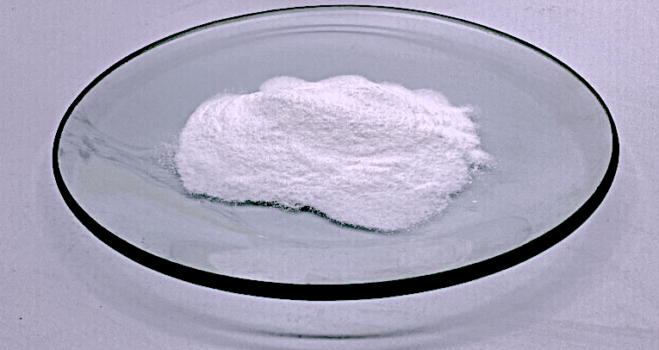
Fig: Appearance of Dapradustat Drug
Determination of Absorption Maxima
Utilizing a UV/visible spectroscopy that assessed many wavelengths in diverse media, the maximum absorption spectra of daprodustat was confirmed.
S.No. | Dissolution Medium | λmax (nm)
1 | Water:ethanol | 223
2 | DMSO:PBS (pH 7.2) | 235
3 | HCL Buffer (pH 1.2) | 213

Preparation of Calibration curve
As shown in Pictures 3.3, 3.4, and 3.5, the daprodustat curves for calibrating was created utilizing a variety of solvent systems in their entirety, including ethanol:water (1:1), the phosphate buffer solution pH 7.2, and HCl buffered pH 1.2, in an appropriate dosage range of 5–50 μg/ml. A UV/visible spectrum detector was used for spectroscopic analysis of the samples that were collected.
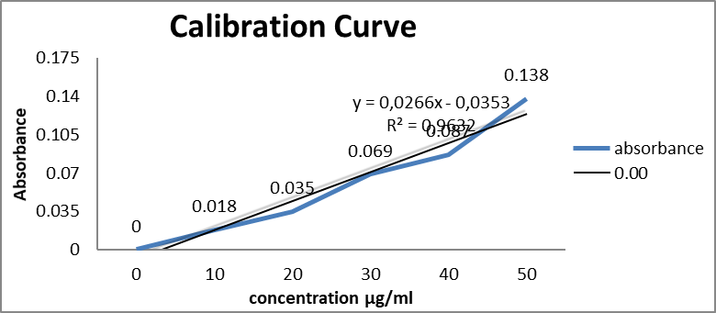
Fig. Calibration curve of daprodustat in ethanol and water (1:1) solvent system
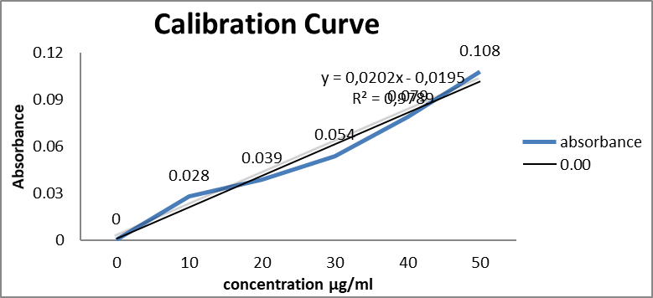
Fig. Calibration of daprodustat in HCL buffered pH 1.2
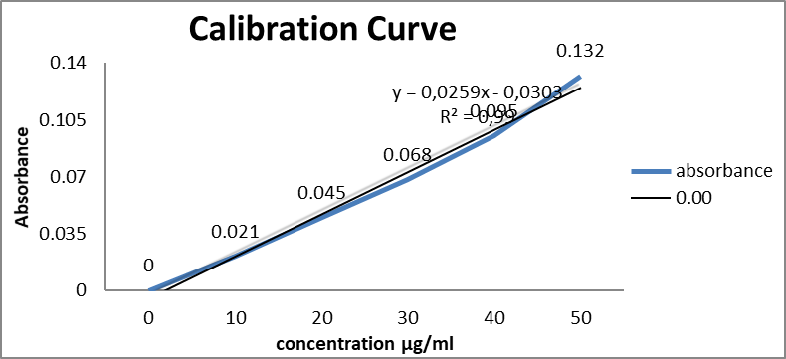
Fig. Calibration of daprodustat in phosphate buffer pH 7.

Drug Characterizations
Drug identification by FTIR

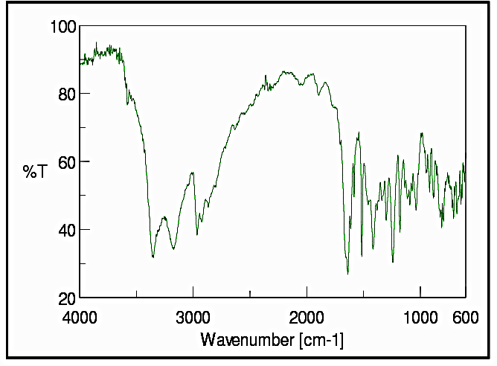
Fig: FTIR spectrum of Daprodustat
Solubility Study
The solubility of daprodustat was tested at 37°C both with and without the presence of several stabilizing agents (Pluronic-F68, Pluronic-127, and Cremophor RH-40). There was a substantial improvement in the soluble condition of pure daprodustat after the inclusion regarding the cremophor RH-40, pluronic F-68, as well as pluronic 127, respectively. Given that the solubilizer has a significant HLB level based on the Freundlich–Ostwald equation, its amphiphilic nature may have contributed to daprodustat's increased solubility.
Drug identification by DSC
At 238°C, the thermogram of daprodustat had a large endothermic maximum.
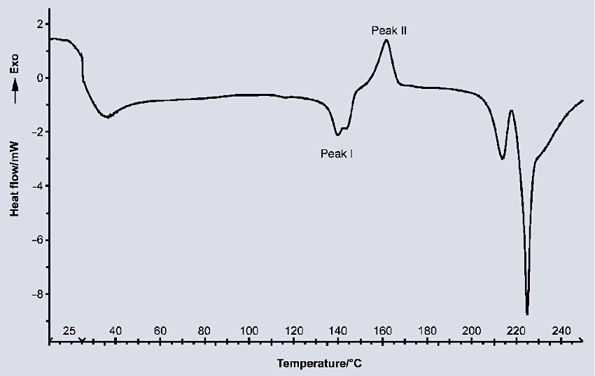
Fig: Thermogram of Daprodustat
Drug’s Melting point
Using a melting equipment, the daprodustat's melting point was determined to be 239 ⁰C.

Drug excipients compatibility study
Daprodustat's compatibility with the formulation's constituents was assessed by DSC and FTIR examinations of the physical arrangement, respectively. The standard daprodustat peak found during the thermogram of the pharmacologic combination demonstrated that there were no thermodynamics interactions of any type involving daprodustat as well as the excipients used to manufacture daprodustat preloaded tiny crystals. Every facet of the distinct peak features of the daprodustat with excipients observed in the FTIR colour spectrum of the physical combination. This proved that the excipients could be used to make nanomaterials loaded with daprodustat.
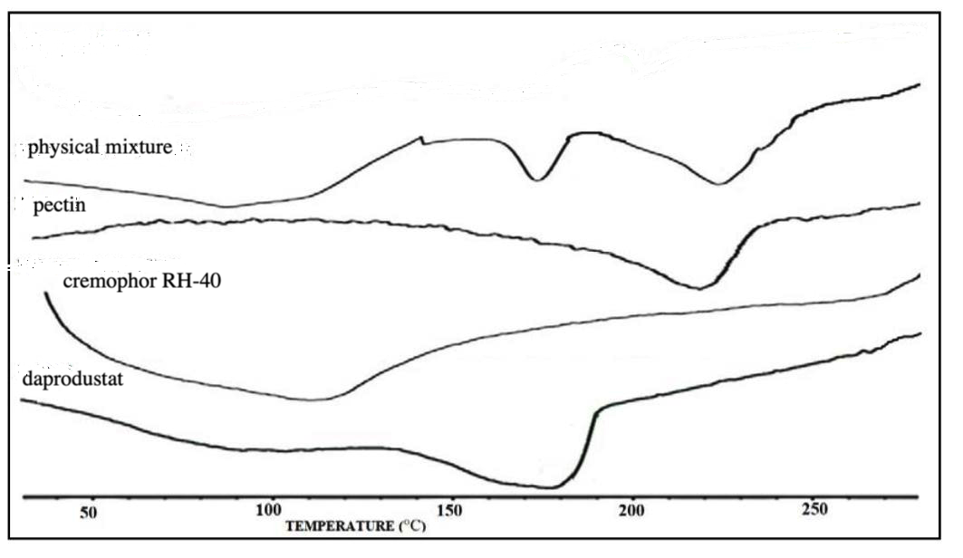
Fig: Physical combination, pectin, cremophor RH-40, and daprodustat DSC thermogram

Development of daprodustat loaded nanocrystal
During the nanonization process, significant energy inputs are frequently needed to scale medications. As a result, an altered anti-solvent nanoprecipitation ultrasonication method was used to create daprodustat nanoparticles. To obtain a durable formulation, several elements have been addressed, such as the kind and amount of stabilizers and the concentrations of pectin and mannitol. Sonication time and amplitude were among the method factors that were improved to create symmetrical polydispersity index (PDI), good zeta possibility, daprodustat information, as well as yield % in nano-sized components.
The results showed that in order to cover the surface of daprodustat while offering steric stabilization, a substantial amount of stabilizers was needed, which would retard or prevent the drug's crystallization.
Optimizing the kind and quantity of stabilizers
Therefore, the results confirmed that a substantial amount of stabilizers was needed to cover daprodustat's appearance and offer steric stabilization of the ankle and this would prevent or postpone the drug's crystal formation.
F. Code | Particle size (nm+-SD) | Polydispersity index (PDI+-SD) | ZP (mV+-SD) | Yield (%+-SD) | Daprodustat contant (%+-SD)
F1 | 4234.34+/-67.54 | 0.67+/-0.09 | 16.12+/-2.14 | 78.78+/-7.45 | 97.12+/-2.34
F2 | 345.67+/-34.56 | 0.66+/-0.04 | -19.23+/-1.45 | 67.34+/-5.34 | 96.34+/-2.67
F3 | 125.67+/-35.45 | 0.56+/-0.05 | -21.23+/-1.67 | 71.21+/-6.23 | 96.56+/-3.45
F4 | 25.45+/-08.45 | 0.19+/-0.04 | -25.56+/-2.17 | 92.34+/-7.23 | 98.89+/-4.10
F5 | 67.45+/-10.56 | 0.45+/-0.05 | -23.12+/-1.89 | 88.12+/-5.23 | 97.11+/-4.12
F6 | 87.23+/-13.43 | 0.40+/-0.05 | -22.45+/-1.23 | 87.12+/-4.56 | 97.66+/-5.33
F7 | 46.67+/-19.43 | 0.41+/-0.04 | -21.23+/-1.57 | 83.34+/-6.34 | 98.10+/-3.45
F8 | 67.45+/-10.56 | 0.38+/-0.06 | -28.15+/-1.68 | 79.67+/-5.67 | 98.06+/-4.56
F9 | 56.78+/-23.44 | 0.45+/-0.02 | -27.14+/-1.56 | 77.45+/-7.34 | 98.34+/-5.11
F10 | 121.34+/-22.34 | 0.33+/-0.05 | -26.32+/-1.98 | 73.88+/-4.77 | 97.68+/-6.44
F11 | 123.11+/-23.56 | 0.28+/-0.05 | -21.33+/-1.11 | 83.34+/-6.77 | 97.89+/-4.89
F12 | 156.13+/-21.22 | 0.34+/-0.06 | -23.44+/-1.77 | 81.56+/-5.76 | 98.23+/-5.12
F13 | 119.21+/-18.23 | 0.31+/-0.07 | -24.23+/-1.90 | 80.11+/-5.44 | 97.98+/-5.67

Table: effects of the quantity and kind of stabilizer on several parameters, respectively

Optimization of process variables
Process variables including sonication time, amplitude, and ZP have a major effect on aggregate size, PDI, and ZP (zeta potential) (Table 3.2). In order to break up the larger nanoparticles and their aggregates, the investigated sonication induced cavitation and shear. According to Table 3.2, extending the length of the sonication frame from 7.5 to 10 minutes considerably decreased the PDI and the dimension of particles of DNCs. However, a prolonged sonication time of 12.5 minutes had hastened the consolidation process and considerably increased the thermodynamic instability of the system, which in turn raised the particle diameters and PDI.
It's likely that the high energy input caused by significant shear stress for an extended amount of time during sonication distorted the stabilizer's obstacle layer and produced an unstable system.
F. Code | Particle Size (nm) | PDI±SD | ZP (mV±SD) | Daprodustat Content | % yield±SD | %mucin efficiency
FD 4 | 40.08±0.34 | 0.35±0.11 | -21.34±2.11 | 98.76±5.21 | 86.67±3.99 | 26.76±0.94
FD 14 | 69.06±1.09 | 0.49±0.34 | -20.45±2.76 | 97.45±6.89 | 82.66±4.56 | 16.67±1.45
FD 15 | 83.12±1.12 | 0.33±0.23 | -19.89±2.76 | 95.89±5.11 | 83.86±5.32 | 22.56±1.78

Table: Effects of sonication intensity on particle size, ZP, PDI, yield, and percentage daprodustat material, in that order
F. Code | Particle Size (nm) | PDI±SD | ZP (mV±SD) | Daprodustat Content | % yield±SD | %mucin binding efficiency
FD 16 | 33.34±2.44 | 0.38±0.19 | -26.76±1.11 | 91.76±3.67 | 78.67±1.99 | 19.56±0.98
FD 17 | 67.06±1.76 | 0.65±0.21 | -23.65±1.76 | 92.65±2.89 | 75.34±1.76 | 16.11±1.65

Table: Effects of sonication intensity on particle size, ZP, PDI, yield, and percentage daprodustat material, in that order
mannitol concentration optimization % w/v
An reason for the improvement in particle size throughout the process of freeze drying might be the fact that the particles' increased thermodynamic inclination to combine is in contrast to the osmotic behaviours of mannitol. The amount of mannitol in the re-dispersed composition had a significant effect on its dimensions, ZP, PDI, along with flow characteristics (Table 3.3). With an angle of repose measurement below thirty degrees, a dry powder with good flowability was produced at a cryogenic preservation concentration equal to 5% w/v.

F. Code | Particle size (nm+-SD) | (PDI+-SD) | ZP (mV+-SD) | Angle of repose | Hausner’s ratio (HR+/-SD) | Carr’s Index (CI%+/-SD | Re-dispersibility time (sec+/-SD)
F 18 | 121.34+/-08.12 | 0.35+/-0.15 | -27.21+/-1.78 | 17.12+/-1.56 | 1.12+/-0.32 | 11.34+/-1.89 | 62.43+/-3.23
F 19 | 190.22+/-10.10 | 026+/-0.34 | -23.34+/-1.67 | 21.23+/-1.78 | 1.23+/-0.12 | 17.13+/-1.67 | 56.43+/-4.21

Table: Effects of % w/v mannitol concentrations on the following, in that order: ZP, PDI, re-dispersibility measure, degree of repose, Hausner's ratio, particle size, and Carr's index

Characterisation of DNCHs
Surface morphology
Daprodustat-loaded nanostructures (DNCHs) coated with pectin were characterized in terms of their crystalline structure and shape using the method of scanning electron microscopy. SEM images revealed that the lyophilized daprodustat nanoparticles were an aggregation of uniformly distributed, almost spheroidal nanomaterials; the same result was seen. The freeze-drying procedure that was carried out before lyophilization could have contributed to the agglomeration of nanomaterials. The standard size of the enhanced DNCHs (NC 24) is in the range of 100 to 100 nanometers.
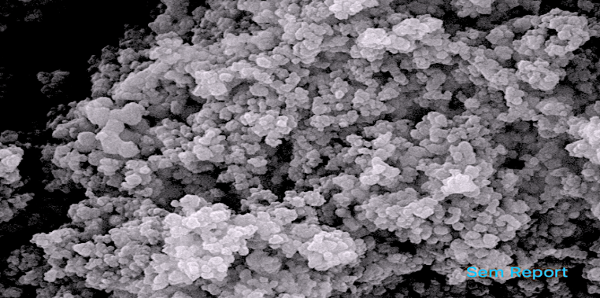
Fig. Scanning electron monograph of optimised DNCHs formulation
Thermal Analysis
The physicochemical arrangement, pectin, coarse daprodustat, cremophor RH-40, and optimum DNCHs variations in temperature are displayed in Figure 3.11. Daprodustat showed a relatively broad an endothermic one surge at 172 Celsius degrees, whereas pectin and cremophor RH-40 each produced a single peak of endothermic energy at 210 and 115 degrees Celsius. In the thermogram of the physical combination, the medication and the cremophor RH-40 had distinct peak values practically at the same spot, suggesting that there was no specific interaction between the two substances. The thermogram from DNCH revealed that the endothermic temperature peak of daprodustat had changed to 165°C. Cremophor -RH 40 and pectin adhering to the topmost layer of daprodustat may have contributed to the endothermic peak's little shift to a higher temperatures.
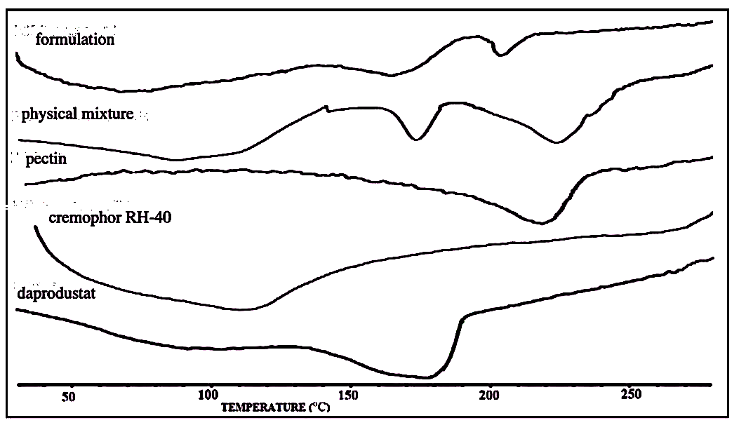
Fig. DSC thermogram of daprodustat, physical mixture, pectin, cremophor RH-40 and formulation

In-Vitro drug analysis
In two hours, peptidin-coated daprodustat tiny crystals (DNCHs) released around 10% of the medication in simulated stomach juice, and the medication maintained to release for another twelve-hour period. On the other hand, within two hours, pure medicine discharged approximately 58 percent of its substance (Figure 3.12). The results demonstrated that the low wetting and water-soluble characteristics of the entirely pure medication were preventing its dissolution. The drug may have released from its connected surface and then diffused through the swelling matrix of polymeric components, causing the initial release that was seen twenty minutes after creation. The extended absorption of the medicine may result in increased localization of the medication inside the lymphatic system. The extended release of the medicine may result in an increased amount of the drug in the lymphatic circulation system, which might enable a reduction in dosage amounts in the future. Pectin-coated DNCHs demonstrated much quicker release of drug properties than the pure medicine in pH gradually dissolving solutions (Figure 3.12). Pectin's water-adsorbing ability, which produces a fully saturated aqueous environment, may be responsible for the rapid drug dissolving rate as well as the superior saturation and dispersion of nanosized compositions. Additionally, the presence of the cremophor RH-60 near the daprodustat-solution phase transition point could have reduced surface tension and sped up the drug's dissolving processes.
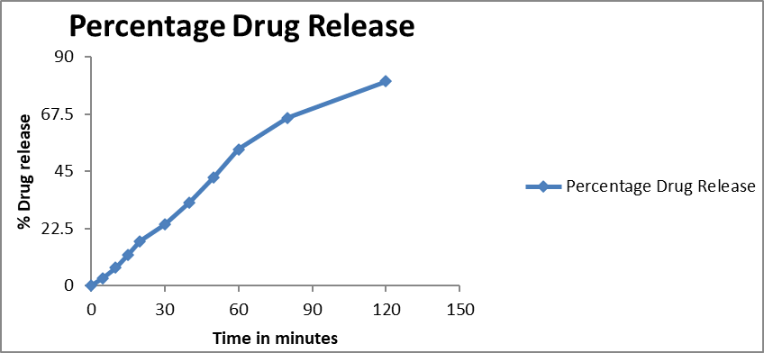
Fig. In-Vitro Drug release
Storage Condition
The improved dosage form's nanoparticle quality parameters (particle dimensions, zeta potential, PDI, which and % drug content) did not alter noticeably while it was stored at ambient temperature or at expedited conditions. This implied that the properties of the formulation had been suitably adjusted to preserve colloidal qualities for long-term, beneficial use. Visual examination under different preservation conditions revealed no appreciable change in the formulation's hue.
Conclusion
The creation of novel deprodustat compositions, including a self-emulsifying composition and pectin-coated deprodustat nanocrystals, was accomplished by effective means. DNCHs nanotechnology in the fight (pectin encased deprodustat nanocrystals) were developed with a variety of process parameters enhanced to get a higher drug load. These factors included the kind of stabilizer, its concentration, the length and intensity of the sonication, the concentrations of pectin and mannitol. Accelerated consistency conditions, an indication that all compositional features had been properly adjusted, and the ability to maintain colloidal properties and drug content over 95% in real time were all displayed by the enhanced formulation.
For this reason, we believe that DNCHS that have been studied might be good choices for the oral treatment of CKD. The formulations demonstrated better CKD treatment, demonstrating their general application for CKD therapy. It is vital to examine both the composition's adaptability at the commercial level and the effectiveness of DNCHS in clinical studies prior to their successful simultaneous use in healthcare facilities.
Reference
- Mahar KM, Caltabiano S, Andrews S, Ramanjineyulu B, Chen L, Young G, Pereira A, Lindsay AC, van den Berg F, Cobitz AR: Clinical Pharmacokinetics of Daprodustat: Results of an Absorption, Distribution, and Excretion Study With Intravenous Microtracer and Concomitant Oral Doses for Bioavailability Determination. Clin Pharmacol Drug Dev. 2021 Dec;10(12):1419-1431. doi: 10.1002/cpdd.1029. Epub 2021 Oct 28. [Article]
- Licea Perez H, Knecht D, Evans CA: Overcoming bioanalytical challenges associated with the separation and quantitation of GSK1278863, a HIF-prolyl hydroxylase inhibitor, and its 14 stereoisomeric metabolites. J Chromatogr B Analyt Technol Biomed Life Sci. 2016 Jan 15;1009-1010:7-16. doi: 10.1016/j.jchromb.2015.11.057. Epub 2015 Dec 4. [Article]
- GSK: GSK reports outcome from US FDA Advisory Committee meeting on daprodustat for anaemia of CKD.
- Caltabiano S, Mahar KM, Lister K, Tenero D, Ravindranath R, Cizman B, Cobitz AR: The drug interaction potential of daprodustat when coadministered with pioglitazone, rosuvastatin, or trimethoprim in healthy subjects. Pharmacol Res Perspect. 2018 Mar 9;6(2):e00327. doi: 10.1002/prp2.327. eCollection 2018 Apr. [Article]
- FDA Approved Drug Products: JESDUVROQ (daprodustat) tablets, for oral use.
- Kumar et al., “Techniques for formulation of nanoemulsion drug delivery system: a review”, Prev. Nutr. Food Sci., 2019, 24(3), pp. 225-234.
- Annisa et al., “Formulation design and evaluation of hydrocortisone-loaded nanoemulsion and nanoemulsion gel for topical delivery”, AIP Conference Proceedings 2120, 050001(2019).
- Shaikh et al., “Formulation and evaluation of nanoemulsion for topical application”, Journal of Drug Delivery & Therapeutics, 2019, 9(4-s), pp. 370-375.
- Rajitha et al., Chaulmoogra oil based methotrexate loaded topical nanoemulsion for the treatment of psoriasis”, Journal of Drug Delivery Science and Technology, 49, 2019, pp. 463-476.
- Chaudhari and Kuchekar, “Development and evaluation of nanoemulsion as a carrier for topical delivery system by box-behnken design”, Asian J Pharm Clin Res, vol 11, issue 8, 2018, pp. 286-293.
- Dhiman et al., “Preparation and evaluation of nano-emulsion formulation by using spontaneous emulsification”, PharmaTutor, 2017, 5(1), pp. 54-58.
- Harika et al., “Formulations and evaluation of nanoemulsion of amphotericin B”, International Journal of Novel Trends in Pharmaceutical Sciences, 2015.
- Rachmawati et al., “Curcumin nanoemulsion for transdermal application: Formulation and evaluation”, Drug Development and Industrial Pharmacy, February 2014.
- Chime et al., “Nanoemulsions- Advances in formulation, characterization and applications in drug delivery”, Intech-open science open minds.
- Bharate S S and Vishwakarma R A, “Impact of Preformulation on drug development”, Expert Opinion on Drug Delivery, 2013, 10(9), pp 1239-1257.
- Hassan S S M, “Colorimetric determination of vitamin D2 (Calciferol)”, Methods in Enzymology, 1980, 37, pp 323-326.
- Luykx D M A M, Peters R J B, van Ruth S M, and Bouwmeester H, “A Review of Ananlytical Methods for the Identification and Characterization of Nano Delivery Systems in Food”, Journal of Agriculture and Food Chemistry, 2008, 56(18), pp 8231- 8247.
- Tugarova A V, Mamchenkova P V, Dyatlova Y A, and Kamnev A A, “FTIR and Raman spectroscopic studies of selenium nanoparticles synthesized by the bacterium Azospirillum thiophilum”, Spectrochimica Acta Part A: Molecular and Biomolecular Spectroscopy, 2018, 192, pp 458-463.
- Villar A M S, Naveros B C, Campmany A C C, Trenchs M A, Rocabert C B and Bellowa L H, “ Design and optimization of self nano-nanoemulsifying drug delivery system (SNEDDS) for enhanced dissolution of gemfibrozil”, International Journal of Pharmaceutics, 2012, 431(1-2), pp 161-175.
- Basalious E B, Shawky N, and Badr-Eldrin S M, “SNEDDS containing bioenhancers for improvement of dissolution and oral absorption of lacidipine I: Development and optimization”, International Journal of Pharmaceutics, 2010, 391(1-2), pp 203-211.

